Text File Analyzer
Software Requirements Specification (SRS)

Team Members:
Brian Guiley
Robert Tieken
Raul Tapia
Jared Cox
Revision History

Date | Revision | Description | Author
10/13/17 | 1.0 | Flowchart | Brian Guiley
10/16/17 | 1.0 | Initial Version of method starters, Lines/Blank Lines | Robert Tieken
10/23/17 | 1.0 | GUI | Brian Guiley
10/28/17 | 1.0 | Word Method | Raul Tapia
10/29/17 | 1.0 | Spaces Method | Jared Cox
10/30/17 | 2.0 | GUI incorporating Word/Spaces and Character | Brian Guiley
11/12/17 | 2.1 | Add Help/Reset to GUI | Brian Guiley
11/15/17 | 3.0 | TextFile Object implement  toString Method in object | Brian Guiley
11/15/17 | 3.1 | OutputMethod – writes to File | Raul Tapia
11/20/17 | 3.2 | Tabs to GUI | Brian Guiley
11/20/17 | 3.3 | Updates to Output Method | Raul Tapia
11/26/17 | 4.0 | Add Word object  Add scrubWord method to remove special characters from words and create linked list of words | Robert Tieken
11/26/17 | 4.1 | readOutput reads history and displays in history tab – creates linked list of TextFiles | Raul Tapia
11/26/17 | 4.2 | Add Date to TextFile object – takes date when analyzed | Jared Cox
11/26/17 | 4.3 | Determine longest word from word linked list and most frequent word from word linked list | Brian Guiley
11/26/17 | 4.4 | Calculate averages from TextFile linked list | Jared Cox
11/27/17 | 4.5 | Update reset option to delete text file – blank all fields | Brian Guiley

Table of Contents

- Project Overview 1
  - Overview 1
- Use Cases 2
  - Use Case Diagram 2
  - Use Case Scenarios 2
- Test Plan 3
  - Test Cases 3
- Project Plan 4
  - Plan for the First Deliverable 4
  - Plan for the Second Deliverable 4
  - Plan for the Third Deliverable 4

Project Overview

Overview
The purpose of this program is to Analyze an inputted text file for specific characteristics through a Graphical User Interface developed in Java. The program will keep a record of files analyzed and statistics across files.

Use Cases

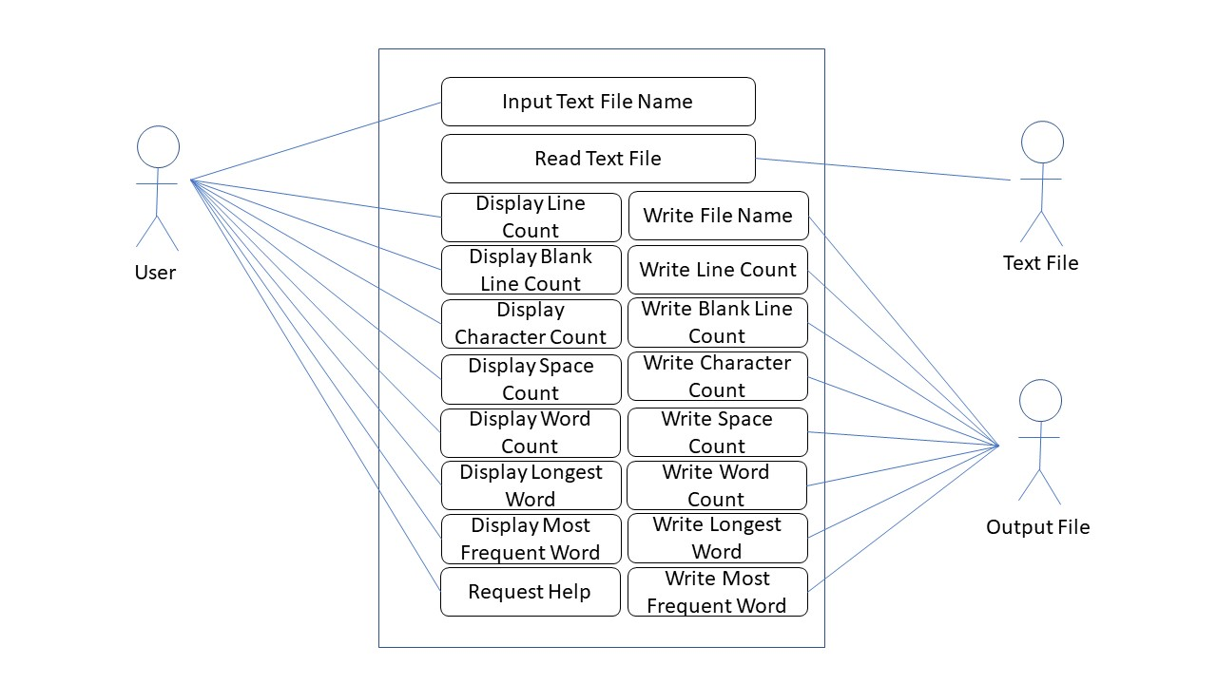
Use Case Diagram

Use Case Scenarios
As a User I will input the text file so that I can analyze it
As a Text File I will provide data to the program to analyze
As an Output File I will receive data to store regarding an analysis of a file.

Test Plan

Test Cases
Specify required behavior of the software product and include parameters such as possible input, expected output, on error, etc.

 | Feature | Description | Possible Input | Expected Output
1 | Upload File | Click on the Browse button and choose a file from directory. | Text File | Analysis fields updated – added to history and output file.  Averages updated
2 | Upload File | Click on the Browse button and choose a file from directory. | Binary File | Error message: invalid file
3 | Upload file | Type filename | Text File | Analysis Fields updated – added to history and output file  Averages updated
4 | Upload file | Type or browse | Text File | Test count of word and scrub word
5 | Upload File | Type or Browse 2 files | Text Files | Ensure averages updated – output file updated

Project Plan

Plan for the First Deliverable
Specify the plan for the first deliverable including the list of tasks with a description, assignment of tasks to team members, etc.

 | Task | Description | Assignment
1 | GUI Panel | Development of GUI Panel using Java Swing API in Eclipse. The panel will include text box for file name and analyze button which will initiate analysis | Brian
2 | Lines/Blank Lines count | Methods to count number of lines and number of blank lines in file | Robert
3 | Spaces count | Method to count number of spaces in file | Jared
4 | Word Count | Method to count number of words in file | Raul

Plan for the Second Deliverable
 | Task | Description | Assignment
1 | Class Diagram | Class Diagram of the project will be drawn in Powerpoint. | Brian
2 | GUI Panel | Add Help menu with information and reset options | Brian

Plan for the Third Deliverable
 | Task | Description | Assignment
1 | Word Linked List | Word linked list – used for longest and most frequent word | Robert
2 | Date String | Create date string when file analyzed | Jared
3 | Output File | Write to output file – read from output file | Raul
4 | Averages | Calculate averages across history (uses text file linked list) | Jared
5 | History Tab | History tab shows file analysis history – formatted for readability | Brian
6 | Averages | Add average fields to History Tab | Brian
7 | ScrubWord | Scrub Word removes special characters from potential words and adds/compares to linked list – increments count if duplicate word – adds to list if new word | Robert
8 | Reset | Reset option clears fields and deletes output file to clear history | Brian

